ITA0305- Mobile Computing
LAB EXPERIMENT
Name: G.Ganesh
Reg NO:192373008

15. Develop a wireframe for a mobile application that addresses challenges related to ad
hoc wireless networks using Figma.

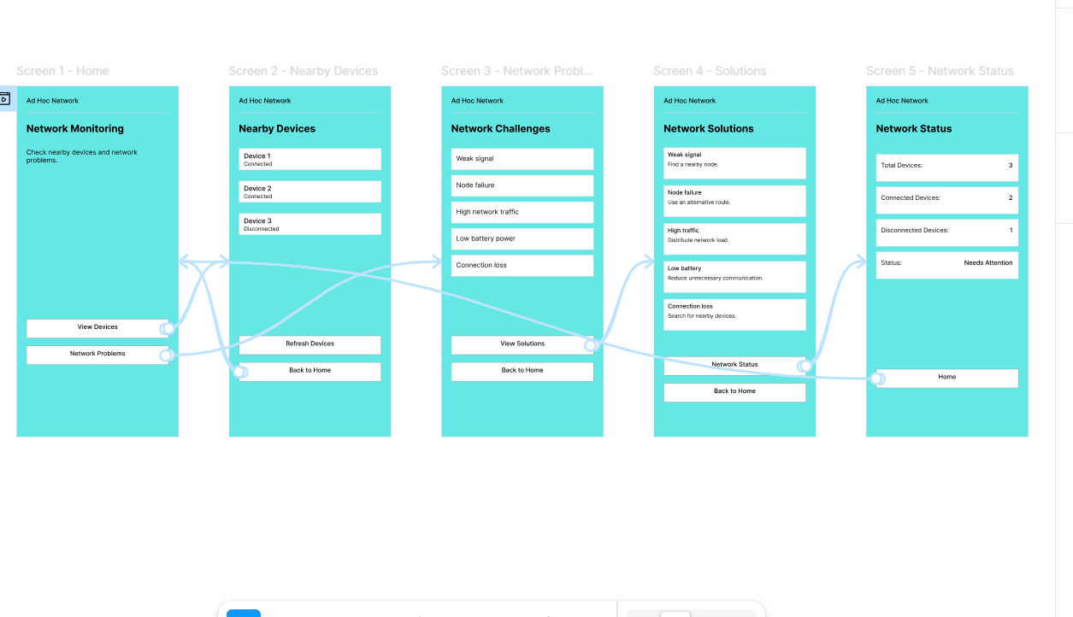

https://www.figma.com/design/C3RmKok0JViIPwrgqEn4Df/program15?node-id=0-1&p=f&t=hCfT0aqIZ84SUBD6-0

